**Pseudocode and diagrams**

**Task 1**

**Import packages**

IMPORT CSV

IMPORT datetime

From datetime import date

**Class**

Class Patient:

FUNCTION INITIALISE Attributes of patient object:

(self, patient_name, date_of_birth, sex, height_of_patient, weight_of_patient,build)

self.calculateBMI = None  
self.Patient_name = patient_name self.date_of_birth = date_of_birth self.Patient_sex = sex

self.build_of_patient = build

self.height_of_patient = float(height_of_patient) self.weight_of_patient = int(weight_of_patient) self.patients_BMI = self.weight_of_patient / (self.height_of_patient ** 2) self.patients_age = calculate_patients_age(date_of_birth)

GET patients name

RETURN Patients name

GET patients age

RETURN patients age

GET patients BMI

Return patients BMI

GET weight class

RETURN class of patients weight

class_of_patients_weight = “”

**Helper functions**

calculate_patients_age(date_of_birth)

CREATE Date_of_birth_list = date_of_birth.split(“/”)

CREATE an integer value to separate the year of the patient

CREATE an integer value to separate the month of the patient

CREATE an integer value to separate the day of the patient

CREATE a date variable to be stored of the patient’s date of birth –

date_of_birth = datetime.date(day, month, year)

ADD date of today

RETURN ((date of today – date of birth) /365).days

set_class_weight_of_patient(patient):

IF patients BMI is less than 18.5

SET class of patients weight = “Underweight”

ELIF if patients BMI is less than or equal to 18.5 or less than or equal to 25

SET class patients weight = “Normal”

IF patients less than 25 or less than or equal to 28

SET class patients weight = “Overweight”

ELIF patients weight more than 28

SET class patients weight = “Obese”

readCSV():

CREATE empty list called List_of_patient

OPEN the csv called **"DADSA 2021 CWK B DATA COLLECTION.csv"**, and set it as patientData

LOOP through each for row in csvreader:

CREATE patient = Patient(row[0], row[1], row[2], row[3], row[4],row[5]) –  *A new patient object is discovered and all data will be set by its constructor*

APPEND the patient to the list of patients

CLOSE patientData

RETURN List_of_patient

**Print Statements**

Patient_fields_task1(patient)

PRINT (Patients name, patients age, patients build, patients BMI, patients weight class)

order_of_weight_patients(obese_patients, underweight_patients, overweight_patients, normalweight_patients):

Weight_counter = 0

PRINT ("Here is a list of patients and are classed by their significant weight")  
PRINT ("Every 10 patients are listed for you to examine, please look through this carefully!")  
INPUT("Please press enter to proceed for task 1. \n")

LOOP through every patient in obese_patients

CALL patients_fields_task1

Increment by 1 if patient is obese

IF Weight_counter has more than 10 patients

PRINT new line

LOOP through every patient in underweight_patients

CALL patients_fields_task1

Increment by 1 if patient is underweight

IF Weight_counter has more than 10 patients

PRINT new line

LOOP through every patient in overweight_patients

CALL patients_fields_task1

Increment by 1 if patient is overweight

IF Weight_counter has more than 10 patients

PRINT new line

LOOP through every patient in normal_patients

CALL patients_fields_task1

Increment by 1 if patient is normal

IF Weight_counter has more than 10 patients

PRINT new line

list_five_worst_patients(underweight_patients, obese_patients):

CREATE empty list called under_weight_male_patients

CREATE empty list called under_weight_female_patients

CREATE empty list called obese_male_patients

CREATE empty list called obese_female_patients

LOOP through patient in underweight_patients

IF it has “M” through the patient.patient_sex class

SET it as under_weight_male_patients

ELSE under_weight_female_patients

LOOP through patient in obese_patients

IF it has “M” through the patient.patient_sex class

SET it as obese_male_patients

ELSE obese_female_patients

*Sorts out the subgroups by their BMI using lambda expression and the reverse method -*

under_weight_male_patients.sort(key=lambda patient: patient.patients_BMI, reverse=True)   
under_weight_female_patients.sort(key=lambda patient: patient.patients_BMI, reverse=True)  
obese_male_patients.sort(key=lambda patient: patient.patients_BMI, reverse=True)  
obese_female_patients.sort(key=lambda patient: patient.patients_BMI, reverse=True)

INPUT("Please press enter to display the worse underweight male patients \n")  
  
PRINT("Worst underweight male patients: \n")  
LOOP through weight in under_weight_male_patients:  
CALL patient_fields_task1(weight)  
PRINT new line   
  
INPUT("Please press enter to display the worse underweight female patients \n")  
  
PRINT("Worst underweight female patients: \n")  
LOOP through weight in under_weight_female_patients:  
CALL patient_fields_task1(weight)  
PRINT new line  
  
INPUT("Please press enter to display the worse obese male patients \n")  
  
PRINT ("Worst obese male patients: \n")  
LOOP through weight in obese_male_patients:  
CALL patient_fields_task1(weight)  
print new line  
  
INPUT ("Please press enter to display the worse obese female patients \n")  
  
PRINT ("Worst obese female patients: \n")  
LOOP through weight in obese_female_patients:  
CALL patient_fields_task1(weight)  
print new line

categorising_weight_of_patients():

CREATE empty list called underweight_patients

CREATE empty list called normaleight_patients

CREATE empty list called overweight_patients

CREATE empty list called obese_patients

CALL read_csv to create a list data structure containing objects of the patient class called patient_list

LOOP through patient in patient_list

SET class_weight_of_patient

IF "Underweight" == patient.class_of_patients_weight:  
APPEND underweight_patients list  
ELIF "Normal" == patient.class_of_patients_weight:  
APPEND normal weight_patients list  
ELIF"Overweight" == patient.class_of_patients_weight:  
APPEND overweight_patients list   
ELIF"Obese" == patient.class_of_patients_weight:  
APPEND obese_patients list

CALL order_of_weight_patients(obese_patients, underweight_patients, overweight_patients, normalweight_patients)  
CALL list_five_worst_patients(underweight_patients, obese_patients)

CALL categorising_weight_of_patients()

**Diagrams for task 1**

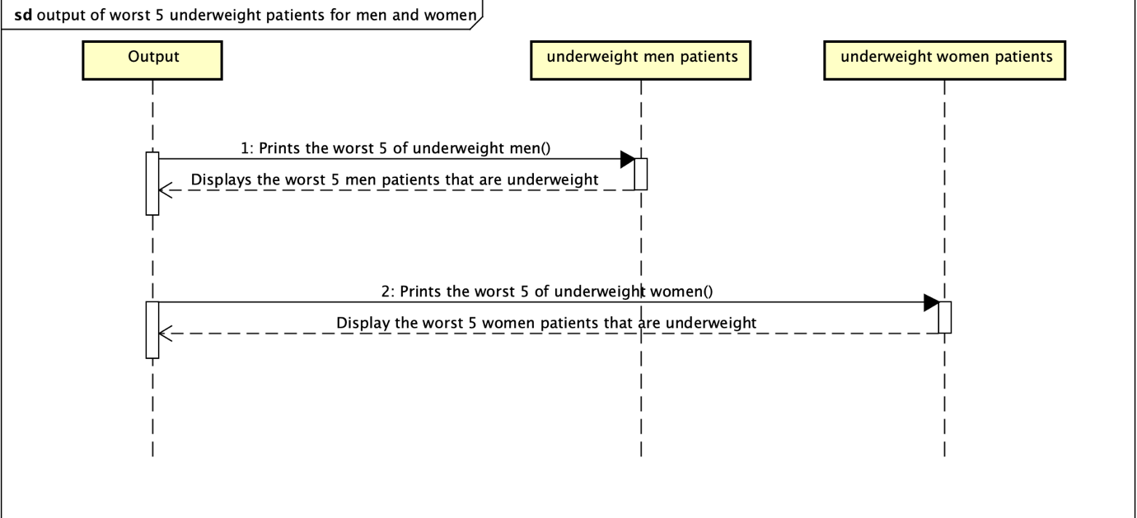

**Task 2**

**Import packages**

IMPORT CSV

IMPORT datetime

From datetime import date

PRINT("Here is a list of patients and are classed by oldest age to youngest age whether they need to be referred to dietitian")  
PRINT("Every 10 patients are listed for you to examine, please look through this carefully!")  
INPUT("Please press enter to proceed for task 2. \n")

**Class**

Class Patient:

FUNCTION INITIALISE Attributes of patient object:

(self, patient_name, date_of_birth, sex, height_of_patient, weight_of_patient,build)

self.calculateBMI = None  
self.Patient_name = patient_name self.date_of_birth = date_of_birth self.Patient_sex = sex

self.build_of_patient = build self.height_of_patient = float(height_of_patient) self.weight_of_patient = int(weight_of_patient) self.patients_BMI = self.weight_of_patient / (self.height_of_patient ** 2) self.patients_age = calculate_patients_age(date_of_birth)

GET patients name

RETURN Patients name

GET patients age

RETURN patients age

GET patients BMI

Return patients BMI

GET weight class

RETURN class of patients weight

CREATE empty list called smoker

CREATE empty list called Asthmatic

CREATE empty list called NJT_or_NGR

CREATE empty list called Hypertension

CREATE empty list called Renal_RT

CREATE empty list called Ileostomy_or_Colostomy

CREATE empty list called Parenteral_Nutrition

class_of_patients_weight = “”

SET topPriority to False

**Helper functions**

calculate_patients_age(date_of_birth)

CREATE Date_of_birth_list = date_of_birth.split(“/”)

CREATE an integer value to separate the year of the patient

CREATE an integer value to separate the month of the patient

CREATE an integer value to separate the day of the patient

CREATE a date variable to be stored of the patient’s date of birth –

date_of_birth = datetime.date(day, month, year)

ADD date of today

RETURN ((date of today – date of birth) /365).days

set_class_weight_of_patient(patient):

IF patients BMI is less than 18.5

SET class of patients weight = “Underweight”

ELIF if patients BMI is less than or equal to 18.5 or less than or equal to 25

SET class patients weight = “Normal”

IF patients less than 25 or less than or equal to 28

SET class patients weight = “Overweight”

ELIF patients weight more than 28

SET class patients weight = “Obese”

readCSV():

CREATE empty list called List_of_patient

OPEN the csv called **"DADSA 2021 CWK B DATA COLLECTION.csv"**, and set it as patientData

LOOP through each for row in csvreader:

CREATE patient = Patient(row[0], row[1], row[2], row[3], row[4],row[5]) –  *A new patient object is discovered and all data will be set by its constructor*

IF row[6] != **' '**:  
SET patient.Smoker as True  
IF row[7] != **''**:  
SET patient.Asthmatic as True  
IF row[8] != **' '**:

SET patient.NJT_or_NGR as True  
IF row[9] != **' '**:

SET patient.Hypertension as True  
IF row[10] != **''**:  
SET patient.Renal_RT as True  
IF row[11] != **''**:  
SET patient.Ileostomy_or_Colostomy as True  
IF row[12] != **''**:  
SET patient.Parenteral_Nutrition as True

APPEND the patient to the list of patients

CLOSE patientData

RETURN List_of_patient

**Print Statements**

Patient_fields_task2(patient)

PRINT (Patients name, patients age, patients build, patients BMI, patients weight class, Top priority)

refer_or_not(referral_list):

CREATE an empty list called refer_or_not_list

LOOP through patient in referral_list

IF (  
 *# uses DeMorgan's law to provide specific Boolean statements  
 # which can be written in different ways for the same effect.* not (not (  
 patient.class_of_patients_weight == "Obese"or patient.class_of_patients_weight ==  
 "Underweight")  
 and not (  
 patient.Hypertension  
 or patient.Asthmatic  
 or patient.Smoker  
 or patient.NJT_or_NGR  
 or patient.Renal_RT  
 or patient.Ileostomy_or_Colostomy  
 or patient.Parenteral_Nutrition))):

APPEND refer_or_not _list   
  
RETURN refer_or_not_list

calculating_who_is_priority(priority_list):

LOOP through patient in priority_list

Count = 0

*# uses DeMorgan's law to provide specific Boolean statements  
# which can be written in different ways for the same effect.*IF (not (not ((patient.Asthmatic or patient.Smoker)  
 and patient.patients_age > 55) and not (patient.class_of_patients_weight == "Obese "and patient.Hypertension))):  
 count += 3 *# this will be counted if patients has all 3*

IF patient is smoker

Increment is added by 1

IF patient is asthmatic

Increment is added by 1

IF patient has condition of NJT or NGR

Increment is added by 1

IF patient has hypertension

Increment is added by 1

IF patient has Renal_RT

Increment is added by 1

IF patient has Ileostomy or Colostomy

Increment is added by 1

If patient has parenteral nutrition

Increment is added by 1

If the count is more than 3

SET the patient as top priority and set it as true

RETURN priority_list

top_priority_or_not():

CALL read_csv to create a list data structure containing objects of the patient class called patient_list

LOOP through patient in patient_list

SET_class weight_of_patient

CALL patient_list to store all the patient’s top priority and attributes into calculating_who_is _priority

CREATE empty list called list_of_patient_who_is_top_priority

LOOP patient in patient_list

IF patient is top_priority

REMOVE from patient_list

APPEND to list_of_patient_who_is_top_priority

*Sorts out the patients by their priority using lambda expression and the reverse method –*

*patient_list.sort(reverse=True, key=lambda patient: patient.topPriority)  
list_of_patient_who_is_top_priority.sort(reverse=True, key=lambda patient: patient.topPriority)*

CREATE variable called top_priority_list from list_of_patient_who_is_top_priority + patient_list

Count = 0

LOOP through patient in top_priority_list

CALL patient_fields_task2

Increment is added by 1

IF count is more than 10

ADD INPUT ("\n Please press enter to proceed for the next 10 patients. \n")

CALL top_priority_or_not()

**Diagrams for task 2**

